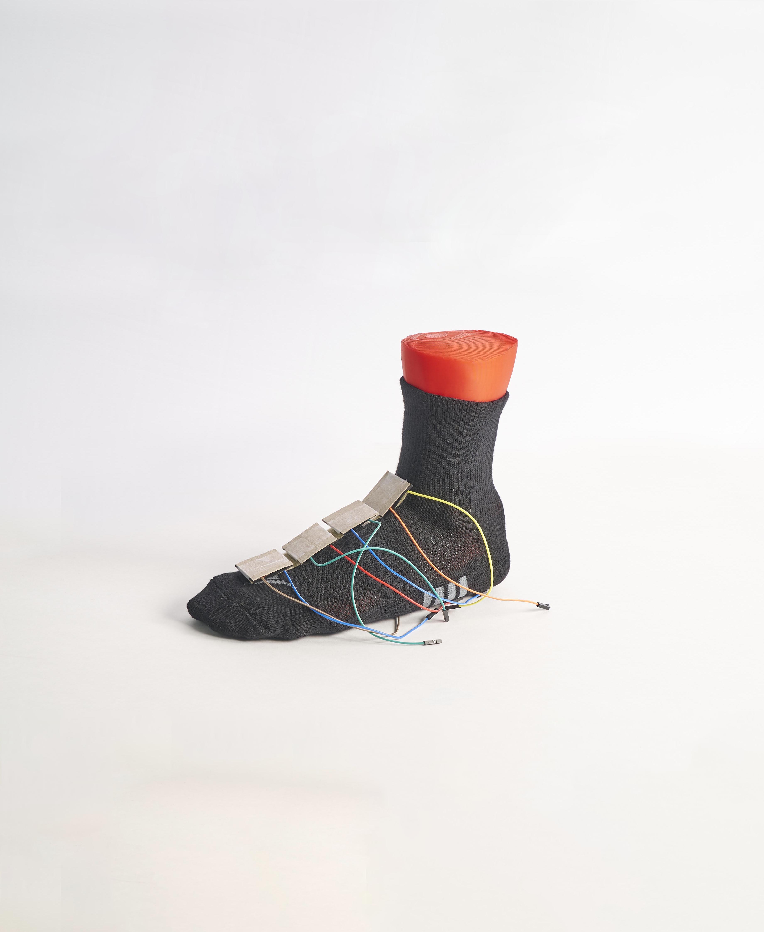

­­

Lesson plan and more resources are

available at: aka.ms/hackingstem

**ASTRO SOCKS**

Designing Astro Socks to protect astronauts’ feet in microgravity

Activity overview

This activity integrates a design challenge around an interesting problem astronauts face while onboard the International Space Station, all while incorporating crucial 21st century technical skills like data science; software, mechanical and electrical engineering, for an authentic learning experience. Emphasis is placed on the importance of combining science and technology to reflect the mechanics of the human body.

View the full lesson plans mapped to NGSS and ISTE standards, materials, and activities to support this unit at aka.ms/astrosocks

Please note that lesson activities will require adult supervision.

v

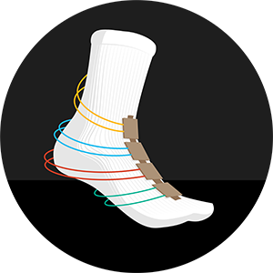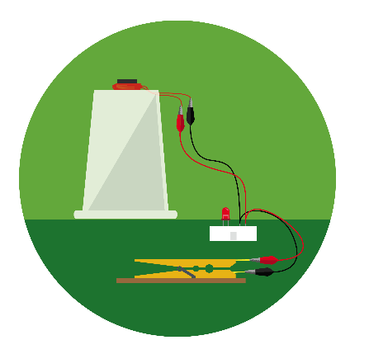

../../../../../Desktop/4x/Asset%202@4x.png

*NASA content is used with NASA's approval, and in accordance with the applicable NASA guidelines, solely for use in Microsoft educational materials. Any downloading, copying and/or reuse of such content is governed by NASA Media Usage Guidelines, NASA Advertising Guidelines, Merchandising Guidelines, and by applicable law.*

Hack our projects

We love innovation and encourage you to hack our projects and make them your own. Submit your ideas at aka.ms/hackingstem

Contents

**02** Activity overview

**03** Things you’ll need

**04** Sensor sock instructions

**07** Space gym instructions

**09** Connect Arduino Uno

**13** Connect micro:bit

**17** Data Streamer set-up

**19** Excel workbook basics

Build and learn

Students build a sensorized sock to visualize the pressure felt on top of your foot. Sensors on the simulator measure the amount of pressure the foot experiences when attached.

Connect your tools

Students connect their sensor-enabled sock to the Excel workbook via an Arduino Uno or micro:bit microcontroller. Utilizing the graphics in Excel, students determine the pressure experienced on the top of your foot during certain tasks.

Visualize the data

Students run trials with the sensorized sock and Space Gym to generate ideas to improve the range of tasks it can accomplish. Using a customized Excel workbook, students can see real-time data input and analyze it.

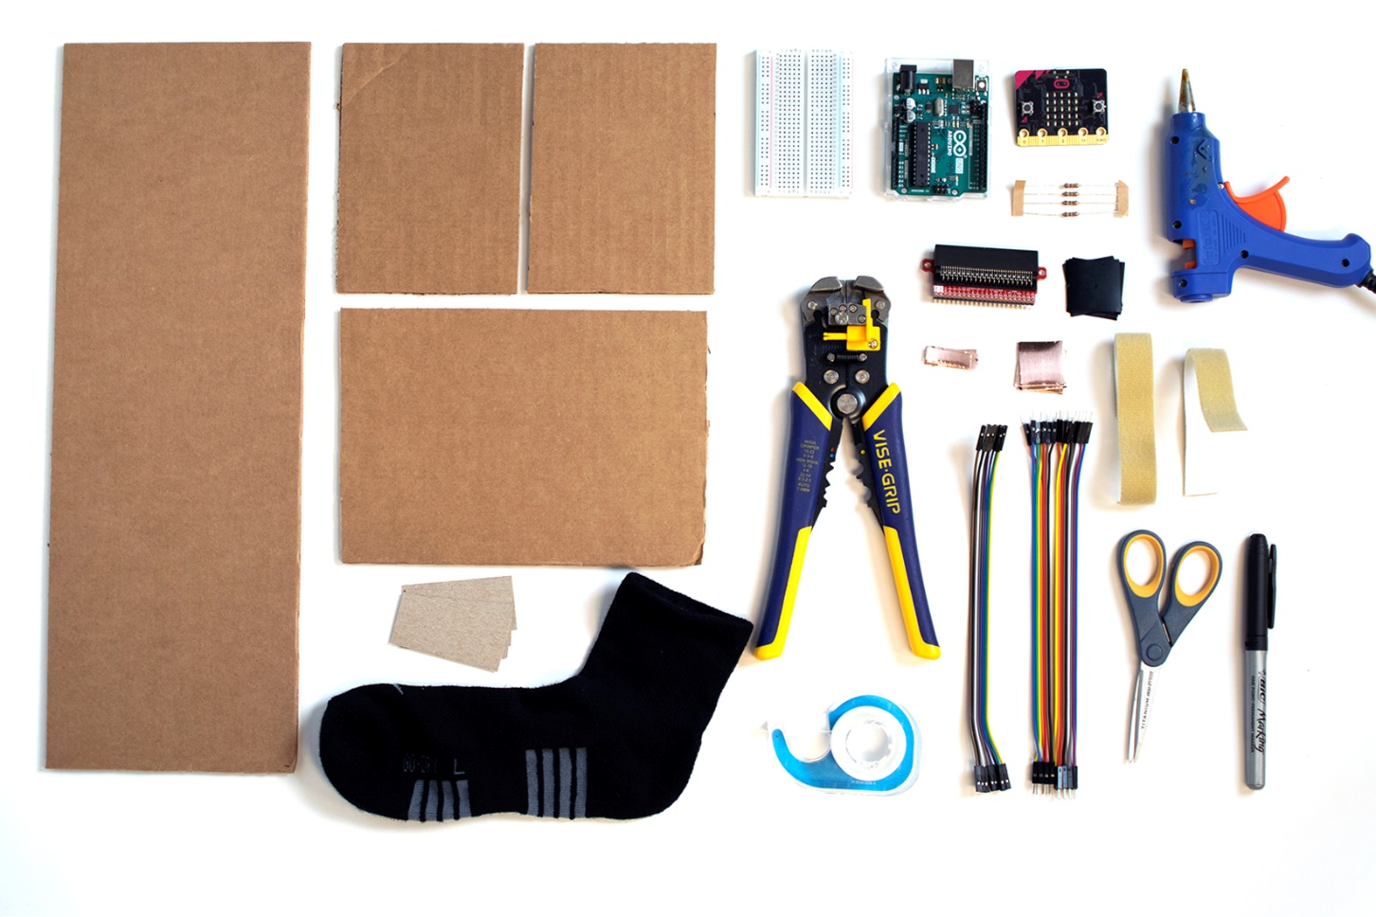­

**G.**

**F.**

**A.**

**H.**

**V.**

**U.**

**I.**

**L.**

**K.**

**O.**

**R.**

**W.**

**S.**

**N.**

**M.**

**J.**

**E.**

**D.  
EE.**

**C.**

**B.**

**J.**

**P.**

|  |  |  |
| --- | --- | --- |
| Things you’ll need to build | | |
| **Sensor Sock materials**  (1) sock **(A)**  (4) 3 x 6 cm cardstock **(B)**  (16) 2.5 x 2.5 cm copper tape **(C)**  (8) 3 x 3 cm Velostat **(D)**  (4) 100 ohm resistors **(E)**  (8) female-to-female jumper wires **(F)**  (14) male-to-male jumper wires **(G)**  clear tape **(H)**  half breadboard **(I)**  15 cm Velcro™ with fabric adhesive back **(G)**  Ribbon **(not pictured)**  **Space gym materials**  (1) 14 cm x 50 cm cardboard **(K)**  (2) 14 cm x 20 cm cardboard **(L)**  (1) 14 cm x 10 cm cardboard **(M)** | | **Arduino materials**  Arduino Uno **(R)**  USB type A to B **(not pictured)**  **Toolkit**  wire strippers **(S)**  ruler **(T)**  scissors **(U)**  marker **(V)**  hot melt tool **(W)**  ***Safety guidelines***  ***Hot Melt Tool***   * *Place it on a level surface to avoid tipping over.* * *Place the electrical cable out of the way to avoid a tripping hazard.* * *Do not touch the tip of the tool or the hot glue coming out of it.*   ***Cutting Tools***   * *Keep the sharp edge away from your body.* * *When cutting small pieces, do not place fingers very close to the blades.*   ***Wire Strippers***   * *Always keep your fingers and hands out of the cutting area.* |

**micro:bit materials**

Edge connector **(N)**

micro:bit **(O)**

Micro USB Cable **(not pictured)**

**Making for a group or need help finding materials?**

View the shopping list to calculate quantities and links to materials at: [aka.ms/astrosocks-materials/en-us](https://aka.ms/astrosocks-materials/en-us)

Build your sensor sock

|  |  |  |
| --- | --- | --- |
|  |  |  |
| **1** | Put the sensor sock onto your foot. |  | **2** | Place the loop (soft) side of your Velcro™ on top of your foot starting at your ankle and extending toward the gap next to your big toe. Mark the Velcro™ where it touches the base of your toes. |
|  |  |  |
|  |  |  |
| **3** | Cut the loop side of the Velcro™. |  | **4** | Peel the backing off the Velcro™ and stick it onto the sensor sock. Take your sock off and set aside. |
|  |  |  |
|  |  |  | |
| **5** | Take one 3 x 6 cm cardstock pieces and mark center of the cardstock at 3 cm. |  | **6** | Align the ruler with center line and fold over the hard edge of the ruler. | |

|  |  |  |
| --- | --- | --- |
|  |  |  |
| **7** | Peel and stick two pieces of copper tape, one on each side of the center line. There should be approximately a 1 cm gap between the copper tape pieces. |  | **8** | Cut one end of two female-to-female jumper wires with scissors. |
|  |  |  |
|  |  |  |
| **9** | Strip 2 cm of insulation from cut wire ends and gently spread the wires out. |  | **10** | Attach stripped wire to the outer end of the copper tape square using another piece of copper tape. Make sure to press the tape down. |
|  |  |  |
|  |  |  | |
| **11** | Double check that the wire positions match the picture above. |  | **12** | Place two pieces of Velostat over copper tape. Make sure your Velostat fully covers the copper tape. | |



|  |  |  |
| --- | --- | --- |
|  |  |  |
| **13** | Fold over the cardstock to sandwich the Velostat and tape the end with the wires together. Ensure that some of the tape covers the wire leads. This is your pressure sensor. |  | **14** | Mark the hook (rough) side of the Velcro™ at 2 cm. |
|  |  |  |
|  |  |  |
| **15** | Make a cut at the 2 cm mark. |  | **16** | Peel and stick the Velcro™ to the sensor. |
|  |  |  |
|  |  |  | |
| **17** | Repeat steps 5-16 to make 4 total sensors. |  | **18** | Attach one sensor to the sock right above the toes (on the Phalanges) and one right below your ankle (Ankle sensor). Place the remaining two sensors equally spaced between the first two (Metatarsal and Tarsal sensors). | |

**N.**

|  |  |  |  |  |  |  |  |  |  |  |  |  |  |  |  |  |  |  |  |  |  |  |  |  |  |  |  |  |  |  |  |  |  |  |  |  |  |  |  |  |  |  |  |  |  |  |  |  |  |  |  |  |  |  |  |  |  |  |  |  |  |  |  |  |
| --- | --- | --- | --- | --- | --- | --- | --- | --- | --- | --- | --- | --- | --- | --- | --- | --- | --- | --- | --- | --- | --- | --- | --- | --- | --- | --- | --- | --- | --- | --- | --- | --- | --- | --- | --- | --- | --- | --- | --- | --- | --- | --- | --- | --- | --- | --- | --- | --- | --- | --- | --- | --- | --- | --- | --- | --- | --- | --- | --- | --- | --- | --- | --- | --- |
| Build your Space Gym   |  |  |  | | --- | --- | --- | | **M.**  **L.**  **N.** |  |  | | **1** | Gather the materials for your Space Gym. Label the 14x 50 cm cardboard “Base.” Label the two 14 x 10cm cardboard pieces “Side A” and “Side B.” Finally, label the 14 x 20 cm square cardboard piece “Tube.” |  | **2** | Take the “Tube” piece and roll into a small tube using the ruler as a straight edge to roll over. | |  | |  |  |  | | **3** | Tape the cardboard roll to hold it together. |  | **4** | Glue the seam together. | |  |  |  | |  |  |  | | | **5** | Glue the cardboard roll to the top of the cardboard piece labeled “Side A.” |  | **6** | Glue the piece labeled “Side B” to the cardboard roll so it is parallel to “Side A”. | |  |  |  |  | | --- | --- | --- | |  |  |  | | **7** | Glue the bottom edges of “Side A” and “Side B” to the edge of the cardboard piece labeled “Base.” |  | **8** | Your Space Gym is ready. Use 2-4 textbooks to add weight to the flat surface of the gym. | |  | |  |  | | |  |  |  | |  |  |  |     **FUN FACT**  **Alligator Skin**  Astronaut Scott Kelly said that during his space station mission the tops of his feet developed rough alligator-like skin because he used them to get around the station using the foot rails.  Attach the sensor for mitigation (Arduino Uno)   |  |  |  | | --- | --- | --- | |  |  |  | | **1** | Gather the materials for the sensor base. |  | **2** | Glue the ribbon onto one side of the cardboard base halfway along the long side. | |  |  |  | |  |  | | **3** | If you are using an Arduino UNO, glue down the microcontroller board and the breadboard to the cardboard base as shown above. |  | |  |  |  | |  |  |  | | |  |  |  | |   Connect the sensors (Arduino Uno) |

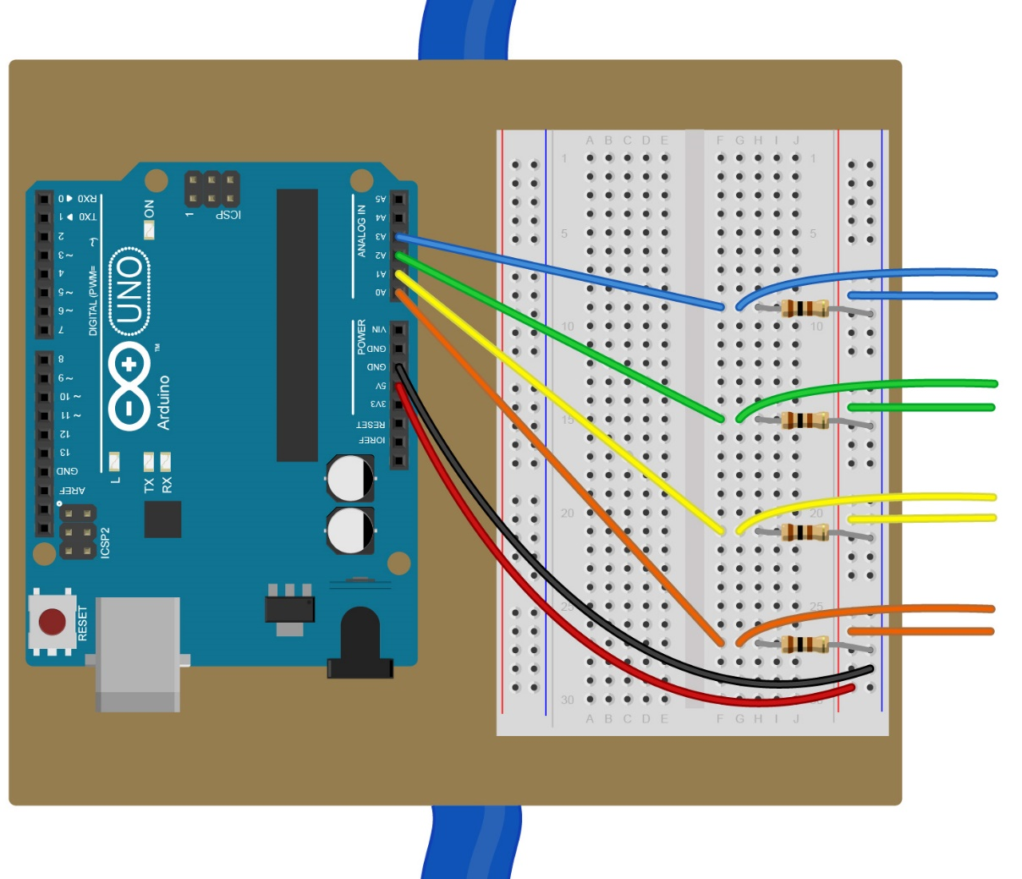

**Phalanges**

**Metatarsals**

**Tarsal**

**Ankle**



|  |  |  |  |  |  |
| --- | --- | --- | --- | --- | --- |
| **1** | Connect a male-to-male jumper wire from the **5V** pin on the Arduinoto the **positive rail of the power bus** on the breadboard. Then connect another male-to-male jumper wire from the **GND** pinto the **negative rail of the power bus**. | |  | | **2** | Connect a male-to-male jumper wire from pin **A0** to an empty row on the breadboard. | |
| **3** | Connect one 100-ohm resistor between the row used in step 2 and the **negative rail of the power bus.** | |  | | **4** | Finally, take the wires from your Phalanges sensor, and connect one into the same row as the resistor and one into the **positive rail of the power bus**. | |
| **5** | Repeat steps 2-4 four more times to complete the wiring. Connect each sensor to the next pin in the Arduino, A1, A2, and A3. | |  | |  | |



**CONCEPT IN ACTION**

**How does a pressure sensor work?**

Velostat is a plastic that is blended with carbon to make it semi-conductive. When pressure is applied to the plastic, the carbon molecules that are dispersed within the plastic get closer together allowing electrical current to flow more easily through the material. The amount of current that is allowed through the plastic is directly proportional to the pressure applied. This allows the microcontroller to read a larger voltage across the plastic as more pressure is applied.

**Troubleshooting**

Is your Arduino board connected but are you not getting any data or is the data is unresponsive? Follow these steps to help troubleshoot the problem.

Check that the Arduino is reading into Data Streamer:

* On the Data Streamer tab, click “Connect Device” and select the Arduino board.
* Click “Start Data” and go to the “Data In” tab. If it is connected successfully, you will see numbers printing to the screen.

Check that the Arduino code was successfully installed on the board. The Arduino program should say “Uploaded Successfully” on the bottom status bar and you should see the Arduino onboard lights blinking.

Check that all the ground (“GND”) wires are connected to the same point.

Check that all your pressure sensor wires are securely attached with copper tape.

If you are getting low or no reading from a sensor, make sure there is nothing between the copper tape squares other than the Velostat.

If you are getting very high readings that don’t change, make sure that the two pieces of copper tape are not touching each other.

Upload Arduino code

|  |  |  |
| --- | --- | --- |
|  |  |  |
| **1** | Start by connecting the Arduino to your computer with the USB cable. Next, you will need to install the Arduino IDE which you can access through the Technical Requirement links at: [aka.ms/hackingSTEM](https://microsoft.sharepoint.com/teams/NASA-HackingSTEMCollaboration/Shared%20Documents/General/Space%20Socks/Middle%20school/Build/aka.ms/hackingSTEM) |  | **2** | Go to [aka.ms/astrosocks-code](https://aka.ms/astrosocks-code) and download the flash code named AstroSocks.ino |
|  |  |  |
|  |  |  |
| **3** | Open your downloaded file to launch the Arduino app. |  | **4** | In the Arduino app, select: Tools > Port > COM 3 (Arduino/Genuino Uno). Your port may be different than COM3. |
|  |  |  |
|  |  |  |
| **5** | Then select Tools > Board: Arduino/Genuino Uno. |  | **6** | Click on the circular right arrow button to upload. |

Attach your sensor for mitigation (micro:bit)

|  |  |  |
| --- | --- | --- |
|  |  |  |
| **1** | Gather the materials for your sensor base. |  | **2** | Glue the ribbon onto one side of the cardboard base halfway along the long side. |
|  |  |  |
|  |  |
| **3** | Insert the micro:bit edge connector breakout board into the breadboard, then glue it down to the cardboard base as shown above. |  |

Connect the sensors (micro:bit)

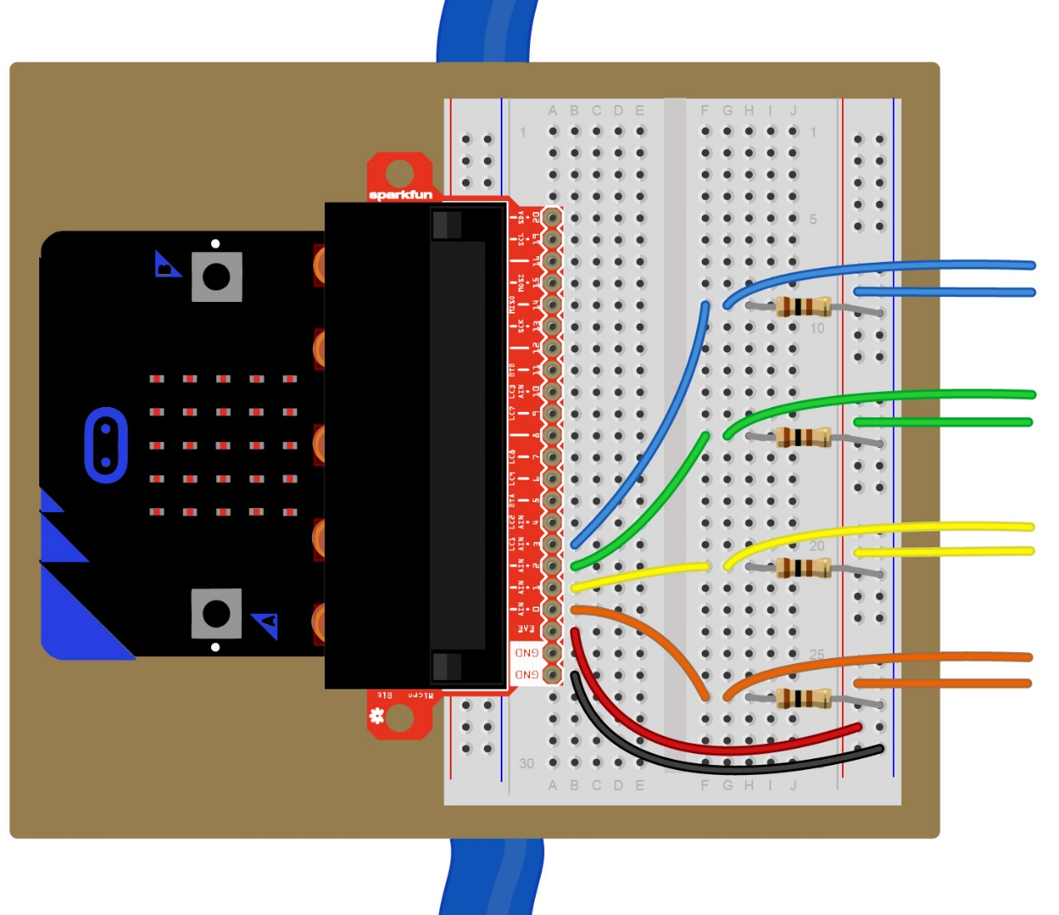

**Phalanges**

**Metatarsals**

**Tarsal**

**Ankle**

|  |  |  |  |  |  |
| --- | --- | --- | --- | --- | --- |
| **1** | Plug the **micro:bit** into the **edge connector.** | |  | | **2** | Connect a male-to-male jumper wire from the **3.3V** pin on the micro:bitto the **positive rail of the power bus** on the breadboard. Then connect another male-to-male jumper wire from **GND** pinto the **negative rail of the power bus**. | |
| **3** | Connect a male-to-male jumper wire from pin **0** to an empty row on the breadboard. | |  | | **4** | Connect one 100-ohm resistor between the row used in step 3 and the **negative rail of the power bus.** | |
| **5** | Finally, take the wires from your Phalanges sensor, and connect one into the same row as the resistor and one into the **positive rail of the power bus**. | |  | | **6** | Repeat steps 2-4 four more times to complete the wiring. Connect each sensor to the next pin, 1, 2, 3, and 4. | |

**CONCEPT IN ACTION**

**How does a pressure sensor work?**

Velostat is a plastic that is blended with carbon to make it semi-conductive. When pressure is applied to the plastic, the carbon molecules that are dispersed within the plastic get closer together allowing electrical current to flow more easily through the material. The amount of current that is allowed through the plastic is directly proportional to the pressure applied. This allows the microcontroller to read a larger voltage across the plastic as more pressure is applied.



**Troubleshooting**

Is your micro:bit board connect but are you not getting any data or is the data unresponsive? Follow these steps to help troubleshoot the problem.

Check that the micro:bit is reading into Data Streamer:

* On the Data Streamer tab, click “Connect Device” and select the micro:bit board.
* Click “Start Data” and go to the “Data In” tab. If it is connected successfully, you will see numbers printing to the screen.

Check that all the ground (“GND”) wires are connected to the same point.

Check that all your pressure sensors wire are securely attached with copper tape.

If you are getting low or no reading from a sensor, make sure there is nothing between the copper tape squares other than the Velostat.

If you are getting very high readings that don’t change, make sure that the 2 pieces of copper tape are not touching each other.



**FUN FACT**

**How big is the Space Station**

The International Space Station is about the size of an American football field or a soccer field.

Upload micro:bit code

|  |  |  |  |
| --- | --- | --- | --- |
|  |  |  |  |
| **1** | Go to [aka.ms/astrosocks-code](https://aka.ms/astrosocks-code) to download the .hex code file. |  |  | **2** | Plug the micro:bit to your computer using a USB cable. [Install the mbed driver](https://os.mbed.com/docs/v5.9/tutorials/windows-serial-driver.html). If you’ve done this before, you won’t have to do it again. |
|  |  |  |  |
|  |  |  |  |
| **3** | In File Explorer, navigate to the micro:bit. It will appear like an external storage device (e.g. thumb drive, hard drive, etc.). |  |  | **4** | Open a second File Explorer window and navigate to the downloads folder. Make sure you can see both windows. |
|  |  |  |  |
|  |  |  |  |
| **5** | Select the .hex file in downloads and drag it to the micro:bit window. |  |  | **6** | Once the LED light stops blinking, the code has been uploaded onto the micro:bit. |

Open Excel and enable Data Streamer

Data Streamer with Excel O365. The O365 subscription includes Excel and the Data Streamer add-in for free.

|  |  |  |
| --- | --- | --- |
|  |  |  |
| **1** | Open Excel 0365. |  | **2** | Click on **File** and choose **Options** located at the bottom of the pane. |
|  |  |  |
| **3** | Choose **Add-ins** in the dialog that opens. |  | **4** | From the **Manage** menu at the bottom of the dialog that opens, choose **COM Add-Ins** and click **Go.** |
|  |  |  |
| **5** | Check the box for **Microsoft Data Streamer**  in the dialog that opens and click **OK.** |  | **6** | You should see a new Data Streamer tab in Excel’s menu ribbon. |

**Data Streamer with Excel O365 desktop version**

For a limited time, Data Streamer can be used with the desktop version of Excel 2016. Download Data Streamer from the Microsoft Store. After installation, Data Streamer will be automatically enabled in Excel.

Get ready to visualize data

**To run the Data Streamer Add-in, make sure you meet these technical requirements:**

* Use a PC running Windows 10 and Excel O365 Desktop.
* Enable the Data Streamer add-in. See instructions on previous page.
* Customized Excel Workbook available at [aka.ms/astrosocks-workbook](https://aka.ms/astrosocks-workbook).

Congratulations! You are now ready to visualize real-time data from the Electroconductivity sensor. To see live data, follow these steps:

|  |  |  |
| --- | --- | --- |
| **1** | Plug the Arduino or micro:bit microcontroller into your computer’s USB port |  | **2** | Click the Data Streamer tab on the Excel ribbon |
| **3** | Click Connect a Device to connect Excel to the microcontroller |  | **4** | Start Data to begin streaming data into Excel |
|  |  |  |
|  |  |  |

To connect the device, plug it into your computer via USB and then click “Connect a Device.”

Once the device is connected, select **Start Data** to begin streaming data into Excel. If you do not click **Start Data** when your device is plugged in, you will not see any live data.

If you have recorded and saved a data file (.csv), you can import it with this button

Test sensors

Get the customized Excel workbook at: [aka.ms/astrosocks-workbook](https://aka.ms/astrosocks-workbook)

**Test Page**

Use this page to test the pressure sensors. Press on each sensor to make sure you are streaming data into Excel. Be sure to check that the sensors are in the right place on your foot. If they are not, remove from the Velcro™ and place in the correct position. The data will read from 0-100 on pressure levels. Once you are satisfied that you are getting readings into Excel, click the “View Live Data” button to continue to next page.

Lab procedure

**Baseline trial**

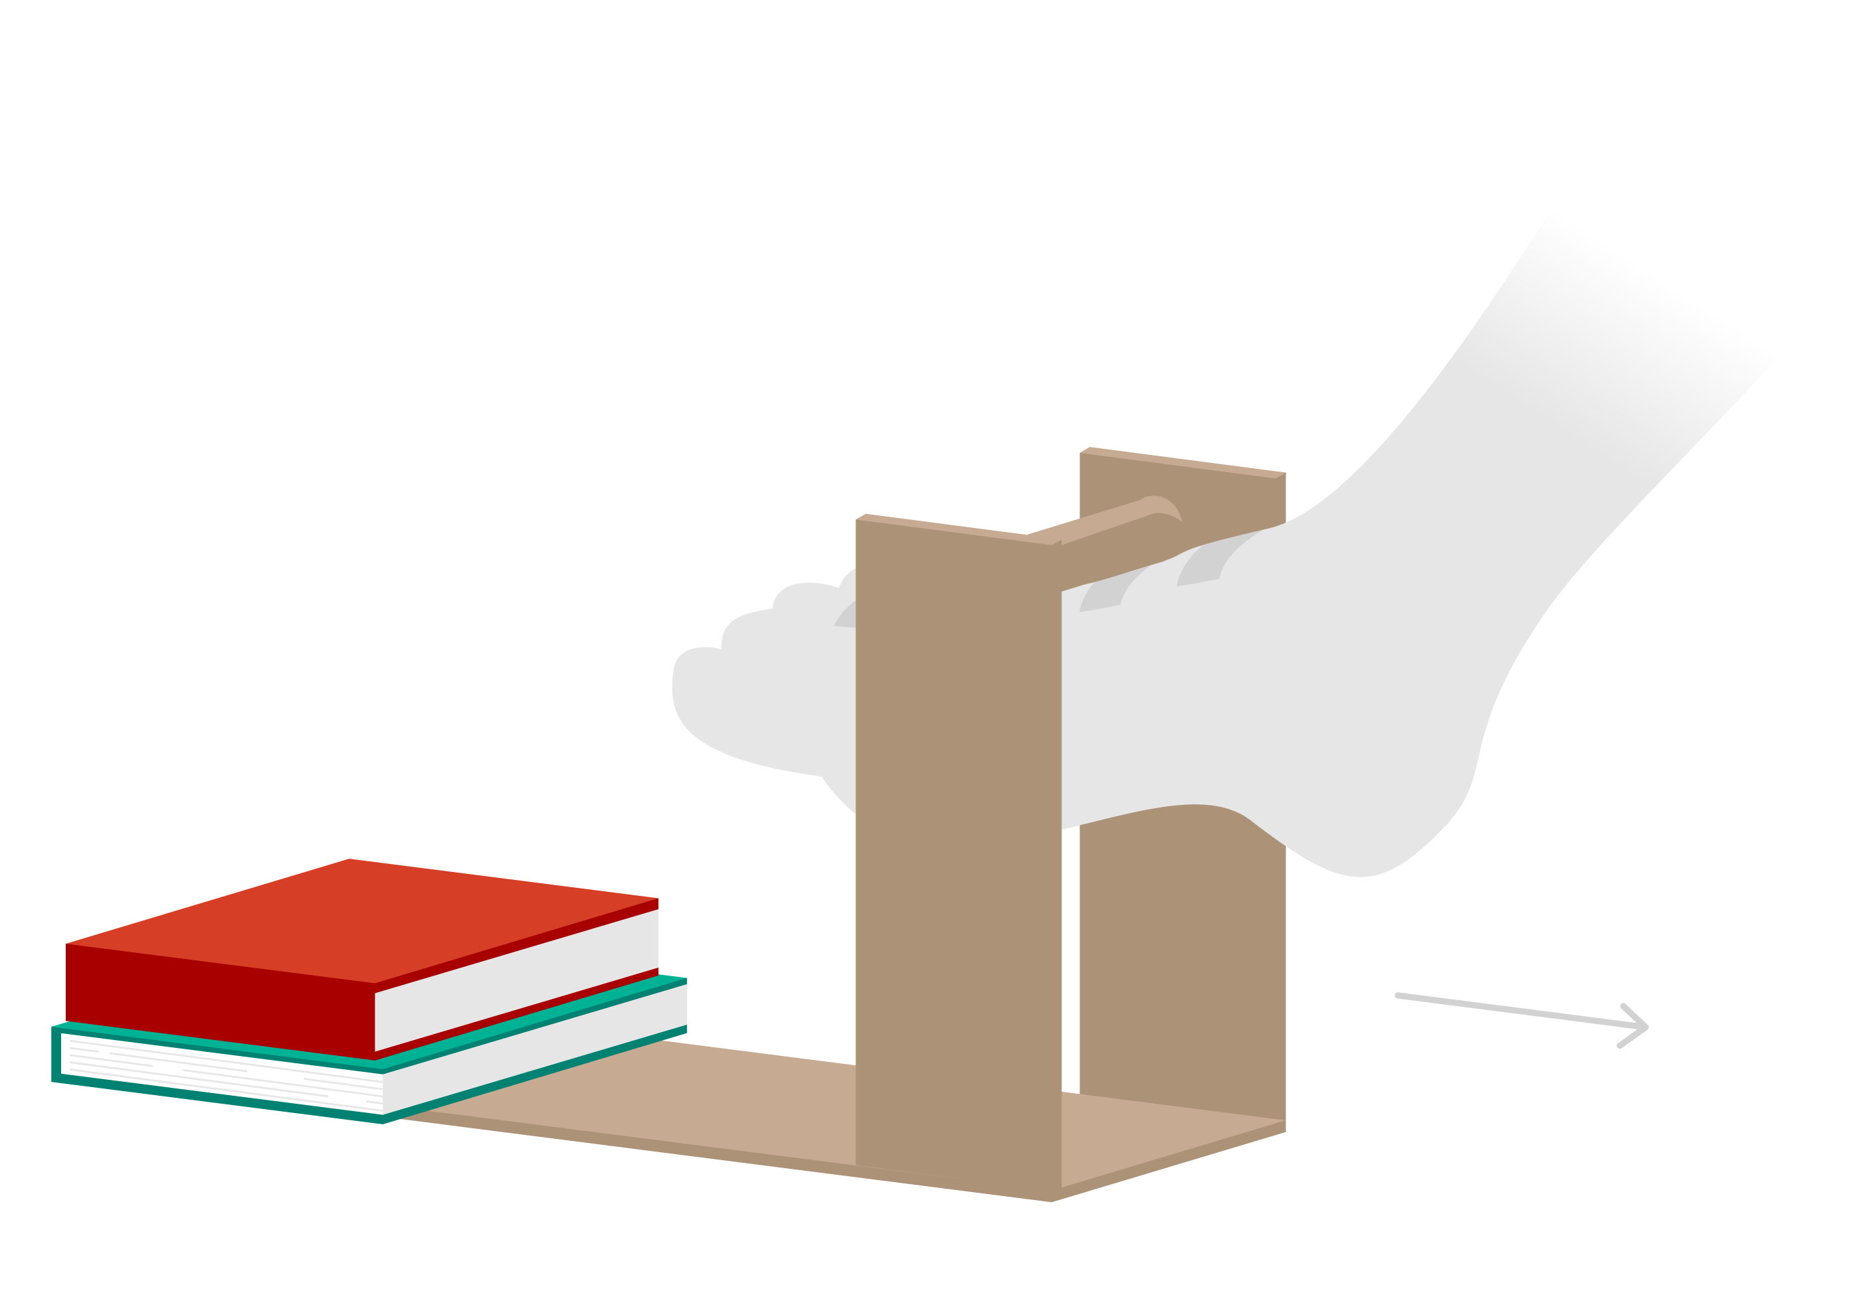

Sensors

|  |  |  |
| --- | --- | --- |
| **1** | Use the setup shown above with the sensor sock for the baseline trial. This setup uses your sensor sock with no mitigation mechanism. | | |
|  |  |  |

**Mitigation trials**

**1** | Carefully put the mitigation build over the sensor sock. Make sure the sensors do not get pulled off the Velcro.

**2** | Repeat the task you performed for the baseline test as closely as possible.

Data collection

Get the customized Excel workbook at: [aka.ms/astrosocks-workbook](https://aka.ms/astrosocks-workbook)

**Capture data**

This page is built for capturing trials. The left side of the worksheet shows live streaming data. Interact with the right side of the page to save trials.

First, save a baseline trial with just the sensor sock and no mitigation in use. In order to get an accurate reading, you will need to first calibrate your sensor, then save three trials to get the average. While leaving your foot at rest, not yet in the testing assembly, click “Calibrate sensors ” to reset all sensors to 0. All additional pressure simply reads from 0.

Second, with the sensor sock calibrated for the baseline, perform the experimental procedure described above. Immediately once the test is done, click “Save trial 1 ”. Repeat the test twice more, saving for trial 2 and trial 3 respectively. These three trials determine the average pressure experienced on each sensor with the given build.

Once complete with the baseline testing, repeat the above steps for each mitigation prototype Astro Sock 1, Astro Sock 2, and Astro Sock 3.

After your testing is complete, continue to the next worksheet to compare and analyze the results.

Data analysis

Get the customized Excel workbook at: [aka.ms/astrosocks-workbook](https://aka.ms/astrosocks-workbook)

**Trial summary**

The last worksheet in the workbook is used to compare the saved trial data. You will see the total pressure, range, and visuals to view each trial average. Use this data to quantify which mitigation design was the best.

The total pressure is the sum of the pressure measured by each sensor. The range is the difference between the maximum pressure and the minimum pressure measured by the sensors. An effective design will lower both the total pressure and the pressure range.